1. Table in local server.

1. Decrypting the original data before migrating to Azure.

1. Saving credentials to log in to the server from ADF during migration.

1. Self Hosted Integration Runtime is created and linked to the Azure account

1. Linked Service for Copy activities Source is created to the DB in local server.

1. Copy activity is created in ADF to transfer the table as a CSV file in ADLS 2.

1. The ADLS is mounted on Synapse during setup, hence, I create External table using Synapse’s feature.

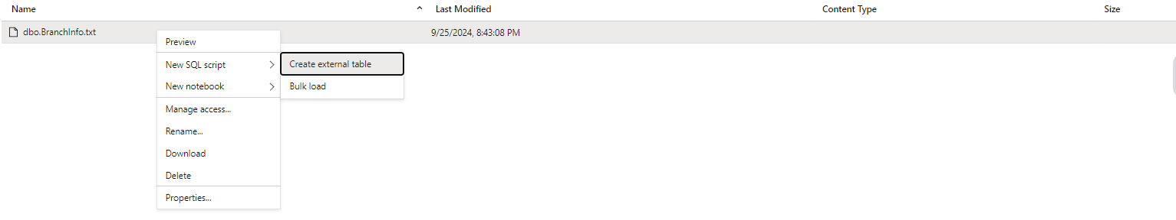

1. The script which was used to make an external table in Synapse and it’s output.

